2403A51015
BATCH –01
Subgroup A
A.1 — [S13A1] Compute per-tractor average from logs (AI completion)
Scenario (agritech):
Context:
You are integrating a agritech telemetry service where each tractor emits periodic measures as CSV lines: `id,timestamp,soil_moist`. Due to flaky connectivity, some lines may be truncated or contain non-numeric values. Ops needs a quick aggregation for dashboards and alert thresholds.

Your Task:
Write a Python function to parse the raw text (multiple lines) and compute per-tractor averages of `soil_moist`. Return a dict {id: avg} and separately compute an overall average.

Data & Edge Cases:
Input contains newlines, optional leading/trailing spaces, and may include malformed rows. Timestamps are ISO-8601 but not needed for math.

AI Assistance Expectation:
Use AI code completion to scaffold the loop, dictionary accumulation (sum and count), and exception handling for malformed rows.

Constraints & Notes:
Prefer O(n) pass; ignore lines that cannot be split into three fields or have non-numeric metric; round averages to 2 decimals.
Sample Input
tr131,2025-01-01T08:00,32.7
tr132,2025-01-02T09:00,34.2
tr133,2025-01-03T010:00,35.7
Sample Output
{'tr131': 32.7, 'tr132': 34.2, 'tr133': 35.7} and overall_avg=34.2
Acceptance Criteria: Correct averages per ID; overall average reported; malformed lines skipped
PROMPT:
Write a Python function that parses CSV lines of tractor telemetry data (format:`id,timestamp,soil_moist`) and computes per-tractor averages of soil moisture, returning a dict {id: avg} and overall average.
CODE :

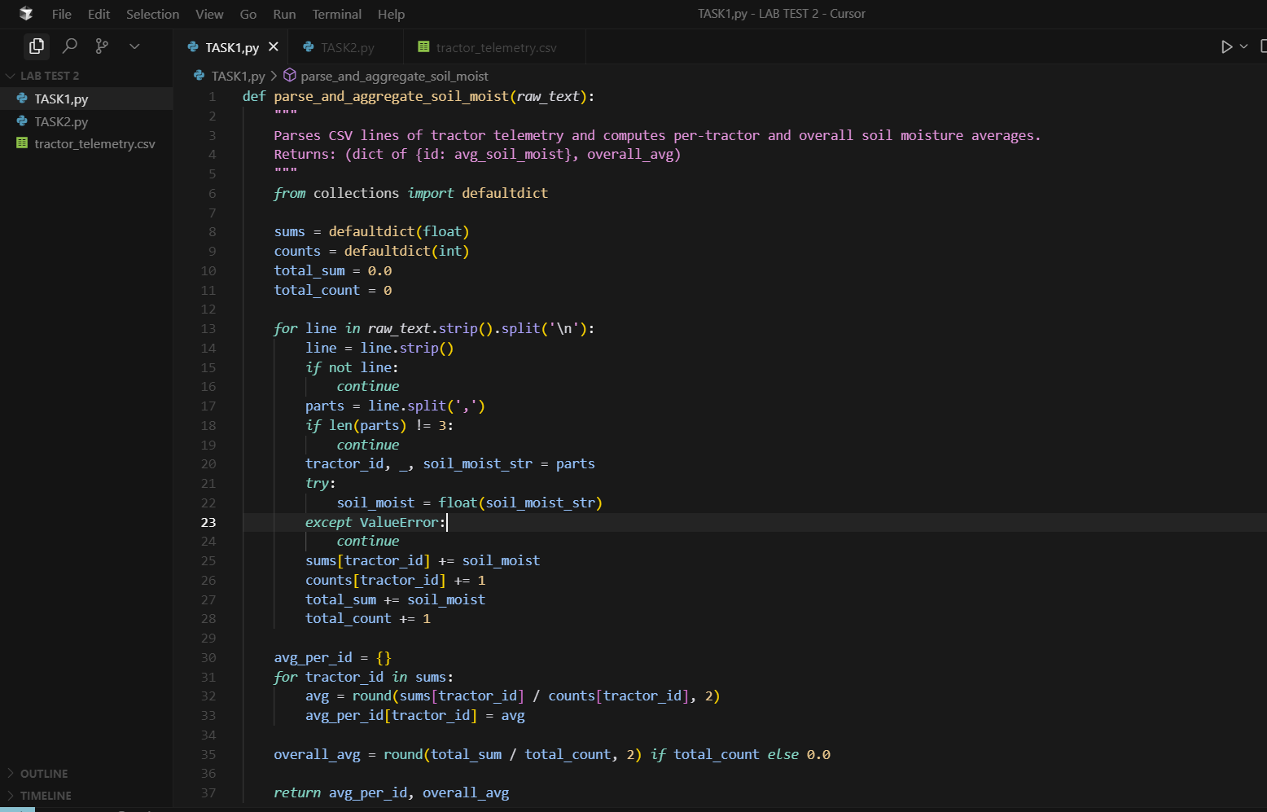

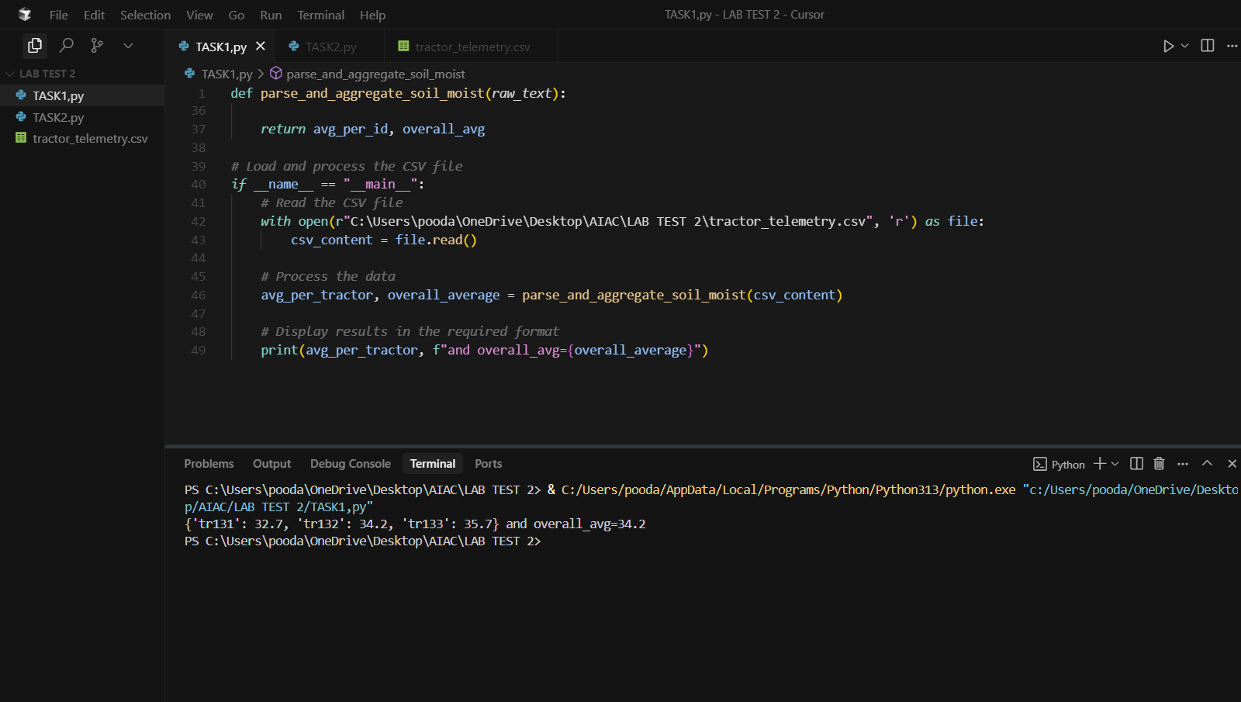

A.2 — [S13A2] Implement YieldTracker with add/remove/summary (AI completion)
Scenario (agritech):
Context:
A microservice in the agritech platform maintains a small in-memory structure to track values keyed by identifier (e.g., order IDs, sensor IDs). Engineers want a minimal class to add, remove, and summarize current values for quick health checks.

Your Task:
Implement a `YieldTracker` class with methods `add(id: str, value: float)`, `remove(id: str)`, and `summary() -> tuple[int, float|None]` returning (count, average).

Data & Edge Cases:
IDs are unique keys. Re-adding the same ID overwrites its value. Removing a missing ID should be safe (no exception). For an empty store, average is None.

AI Assistance Expectation:
Ask AI to generate the class skeleton with docstrings and type hints, then refine method behavior and add a quick usage example.

Constraints & Notes:
Keep state in a dict; O(1) per operation; return rounded average to 2 decimals (when non-empty).
Sample Input
[{'op': 'add', 'id': 'a1', 'value': 22}, {'op': 'add', 'id': 'b2', 'value': 17}, {'op': 'remove', 'id': 'a1'}, {'op': 'add', 'id': 'c3', 'value': 19}]
Sample Output
count=2, avg=18.0
Acceptance Criteria: Handles add/remove; correct count and average; safe on missing IDs
PROMPT :
Create a YieldTracker class that handles add/remove operations on ID-value pairs and provides summary statistics. The class should support adding values (with overwrite), safely removing IDs (even if missing), and returning count and average of current values.

CODE :

